Laboratory Project: Open Source Software Lab 18B17CI507

 | Name/ |  | Dept: CSE
  S.No. | Enroll NO | Name | CGPA
  1 | 191B262 | SNEH SINGH | 8.3
  2
  3
 | Expt. Title:  Description | “Credit Card Fraud Detection “  This Project On about Credit Cards Transaction, it tells us your transaction is frauds or Genuine. This is a front and Back End Project. IN Back End, using DecisionTreeClassifier() we make a model that fits the model on data. Data are available in Kaggle,  In data, we have 5 rows and 31 columns.  In the Front end, we use python(Tkinter), and using Twilio we send messages to users. | Date: 21-12-2021
 | Approach/  Algorithms: | - First we import important library or build in function like pandas ,numpy and sklearn.  - Than we read csv file using read_csv.  - Than we create model using DecisionTreeClassifier().  - Than we fit in model and find score.  - Than we predict the Score.  - For front, we using python(Tkinter). we make frame,screen and submit button.  - When user press submit button than using twilio we send massage to user.  - End
 | Test/code: | import numpy as np  import pandas as pd  import matplotlib.pyplot as plt  import seaborn as sns  data=pd.read_csv(r"C:\Users\Dell\Desktop\oss-lab\project\creditcard.csv")  data.head()  print(data.columns)  df.describe()  8 rows × 31 columns  df.shape  data.shape  non_fraud = len(df[df.Class == 0])  fraud = len(df[df.Class == 1])  fraud_percent = (fraud / (fraud + non_fraud)) * 100  print("Number of Genuine transactions: ", non_fraud)  print("Number of Fraud transactions: ", fraud)  print("Percentage of Fraud transactions: {:.4f}".format(fraud_percent))  labels = ["Genuine", "Fraud"]  count_classes = df.value_counts(df['Class'], sort= True)  count_classes.plot(kind = "bar", rot = 0)  plt.title("Visualization of Labels")  plt.ylabel("Count")  plt.xticks(range(2), labels)  plt.show()  from sklearn.preprocessing import RobustScaler  rs = RobustScaler()  df['scaled_amount'] = rs.fit_transform(df['Amount'].values.reshape(-1,1))  df['scaled_time'] = rs.fit_transform(df['Time'].values.reshape(-1,1))  df.drop(['Time', 'Amount'], axis=1, inplace=True)  scaled_amount = df['scaled_amount']  scaled_time = df['scaled_time']  df.drop(['scaled_amount', 'scaled_time'], axis=1, inplace=True)  df.insert(0, 'scaled_amount', scaled_amount)  df.insert(0, 'scaled_time', scaled_time)  df.head()  5 rows × 31 columns  In [13]:  x = df.drop(["Class"], axis= 1)  y = df["Class"]  x = df.drop(["Class"], axis= 1)  y = df["Class"]  from sklearn.model_selection import train_test_split  (x_train, x_test, y_train, y_test) = train_test_split(x, y, test_size= 0.3, random_state= 42)  print("Shape of train_X: ", x_train.shape)  print("Shape of test_X: ", x_test.shape)  from sklearn.tree import DecisionTreeClassifier  from sklearn.ensemble import RandomForestClassifier  from sklearn.tree import DecisionTreeClassifier  from sklearn.linear_model import LogisticRegression  from sklearn.metrics import confusion_matrix, precision_score, recall_score, f1_score, confusion_matrix, precision_recall_curve, accuracy_score  def metrics(actuals, predictions):  print("Accuracy: {:.5f}".format(accuracy_score(actuals, predictions)))  print("Precision: {:.5f}".format(precision_score(actuals, predictions)))  print("Recall: {:.5f}".format(recall_score(actuals, predictions)))  print("F1-score: {:.5f}".format(f1_score(actuals, predictions)))  dt = DecisionTreeClassifier()  dt.fit(x_train, y_train)  y_pred = dt.predict(x_test)  cnf_matrix = confusion_matrix(y_test, y_pred)  sns.heatmap(pd.DataFrame(cnf_matrix), annot=True, cmap="YlGnBu", fmt='g')  plt.ylabel('Actual Label')  plt.xlabel('Predicted Label')  inputs = df.drop('Class',axis='columns')  target = df['Class']  from sklearn import tree  model = tree.DecisionTreeClassifier()  model.fit(inputs, target)  model.score(inputs,target)  model.predict([[0,9,8,1,1,2,3,45,6,7,8,9,0,1,2,3,4,5,1,2,1,1,1,1,1,1,1,1,1,8]])  from twilio.rest import Client  from random import *  from tkinter import *  def submit():  y=model.predict([[1,1,9,1,1,1,1,1,0,1,0,1,0,1,1,1,0,1,1,2,1,1,1,1,1,1,1,1,1,0]])  x = randint(0,1)  print(x)  if x==0:  client=Client("AC90995e0bfd177bdc7e03b425f4c30342","c05086903e80c75395710eece0abc016")  client.messages.create(to=["+919340575521"],from_ = "+17174529416",body="from Juet Cyber Crime \n Your transactions is Genuine \nthanks :)")  else:  client=Client("AC90995e0bfd177bdc7e03b425f4c30342","c05086903e80c75395710eece0abc016")  client.messages.create(to=["+919340575521"],from_ = "+17174529416",body=" from JUET Cyber Crime \nYour transactions is Fraud detected \nthanks :). ")  def click(event):  text=event.widget.cget("text")  print(text)  Scvalue.set(Scvalue.get() + text)  screen.update()  root=Tk()  root.geometry("500x500")  root.title("JUET CYBER CRIME")  root.iconbitmap(r'C:\Users\Dell\Desktop\oss-lab\project\images.ico')  Scvalue=StringVar()  Scvalue.set(" ")  screen=Entry(root,textvar=Scvalue,font="lucida 40 bold")  screen.pack(fill=X,ipadx=8,pady=10,padx=10)  f=Frame(root,bg="grey")  b=Button(f,text="0",font="lucida 20 bold",padx=28,pady=22)  b.bind('<Button-1>',click)  b.pack(padx=10,pady=10)  b=Button(f,text="1",font="lucida 20 bold",padx=28,pady=22)  b.bind('<Button-1>',click)  b.pack(padx=10,pady=10)  b=Button(f,text="submit",font="lucida 40 bold",padx=10,pady=10,command=submit )  b.pack(padx=10,pady=10)  f.pack()  root.mainloop()
  ount | 284807.000000 | 2.848070e+05 | 2.848070e+05 | 2.848070e+05 | 2.848070e+05 | 2.848070e+05 | 2.848070e+05 | 2.848070e+05 | 2.848070e+05 | 2.848070e+05 | ... | 2.848070e+05 | 2.848070e+05 | 2.848070e+05 | 2.848070e+05 | 2.848070e+05 | 2.848070e+05 | 2.848070e+05 | 2.848070e+05 | 284807.000000 | 284807.000000
  mean | 94813.859575 | 3.918649e-15 | 5.682686e-16 | -8.761736e-15 | 2.811118e-15 | -1.552103e-15 | 2.040130e-15 | -1.698953e-15 | -1.893285e-16 | -3.147640e-15 | ... | 1.473120e-16 | 8.042109e-16 | 5.282512e-16 | 4.456271e-15 | 1.426896e-15 | 1.701640e-15 | -3.662252e-16 | -1.217809e-16 | 88.349619 | 0.001727
  std | 47488.145955 | 1.958696e+00 | 1.651309e+00 | 1.516255e+00 | 1.415869e+00 | 1.380247e+00 | 1.332271e+00 | 1.237094e+00 | 1.194353e+00 | 1.098632e+00 | ... | 7.345240e-01 | 7.257016e-01 | 6.244603e-01 | 6.056471e-01 | 5.212781e-01 | 4.822270e-01 | 4.036325e-01 | 3.300833e-01 | 250.120109 | 0.041527
  min | 0.000000 | -5.640751e+01 | -7.271573e+01 | -4.832559e+01 | -5.683171e+00 | -1.137433e+02 | -2.616051e+01 | -4.355724e+01 | -7.321672e+01 | -1.343407e+01 | ... | -3.483038e+01 | -1.093314e+01 | -4.480774e+01 | -2.836627e+00 | -1.029540e+01 | -2.604551e+00 | -2.256568e+01 | -1.543008e+01 | 0.000000 | 0.000000
  25% | 54201.500000 | -9.203734e-01 | -5.985499e-01 | -8.903648e-01 | -8.486401e-01 | -6.915971e-01 | -7.682956e-01 | -5.540759e-01 | -2.086297e-01 | -6.430976e-01 | ... | -2.283949e-01 | -5.423504e-01 | -1.618463e-01 | -3.545861e-01 | -3.171451e-01 | -3.269839e-01 | -7.083953e-02 | -5.295979e-02 | 5.600000 | 0.000000
  50% | 84692.000000 | 1.810880e-02 | 6.548556e-02 | 1.798463e-01 | -1.984653e-02 | -5.433583e-02 | -2.741871e-01 | 4.010308e-02 | 2.235804e-02 | -5.142873e-02 | ... | -2.945017e-02 | 6.781943e-03 | -1.119293e-02 | 4.097606e-02 | 1.659350e-02 | -5.213911e-02 | 1.342146e-03 | 1.124383e-02 | 22.000000 | 0.000000
  75% | 139320.500000 | 1.315642e+00 | 8.037239e-01 | 1.027196e+00 | 7.433413e-01 | 6.119264e-01 | 3.985649e-01 | 5.704361e-01 | 3.273459e-01 | 5.971390e-01 | ... | 1.863772e-01 | 5.285536e-01 | 1.476421e-01 | 4.395266e-01 | 3.507156e-01 | 2.409522e-01 | 9.104512e-02 | 7.827995e-02 | 77.165000 | 0.000000
  max | 172792.000000 | 2.454930e+00 | 2.205773e+01 | 9.382558e+00 | 1.687534e+01 | 3.480167e+01 | 7.330163e+01 | 1.205895e+02 | 2.000721e+01 | 1.559499e+01 | ... | 2.720284e+01 | 1.050309e+01 | 2.252841e+01 | 4.584549e+00 | 7.519589e+00 | 3.517346e+00 | 3.161220e+01 | 3.384781e+01 | 25691.160000 | 1.000000
  scaled_time | scaled_amount | V1 | V2 | V3 | V4 | V5 | V6 | V7 | V8 | ... | V20 | V21 | V22 | V23 | V24 | V25 | V26 | V27 | V28 | Class
  0 | -0.994983 | 1.783274 | -1.359807 | -0.072781 | 2.536347 | 1.378155 | -0.338321 | 0.462388 | 0.239599 | 0.098698 | ... | 0.251412 | -0.018307 | 0.277838 | -0.110474 | 0.066928 | 0.128539 | -0.189115 | 0.133558 | -0.021053 | 0
  1 | -0.994983 | -0.269825 | 1.191857 | 0.266151 | 0.166480 | 0.448154 | 0.060018 | -0.082361 | -0.078803 | 0.085102 | ... | -0.069083 | -0.225775 | -0.638672 | 0.101288 | -0.339846 | 0.167170 | 0.125895 | -0.008983 | 0.014724 | 0
  2 | -0.994972 | 4.983721 | -1.358354 | -1.340163 | 1.773209 | 0.379780 | -0.503198 | 1.800499 | 0.791461 | 0.247676 | ... | 0.524980 | 0.247998 | 0.771679 | 0.909412 | -0.689281 | -0.327642 | -0.139097 | -0.055353 | -0.059752 | 0
  3 | -0.994972 | 1.418291 | -0.966272 | -0.185226 | 1.792993 | -0.863291 | -0.010309 | 1.247203 | 0.237609 | 0.377436 | ... | -0.208038 | -0.108300 | 0.005274 | -0.190321 | -1.175575 | 0.647376 | -0.221929 | 0.062723 | 0.061458 | 0
  4 | -0.994960 | 0.670579 | -1.158233 | 0.877737 | 1.548718 | 0.403034 | -0.407193 | 0.095921 | 0.592941 | -0.270533 | ... | 0.408542 | -0.009431 | 0.798278 | -0.137458 | 0.141267 | -0.206010 | 0.502292 | 0.219422 | 0.215153 | 0
 | Results: | 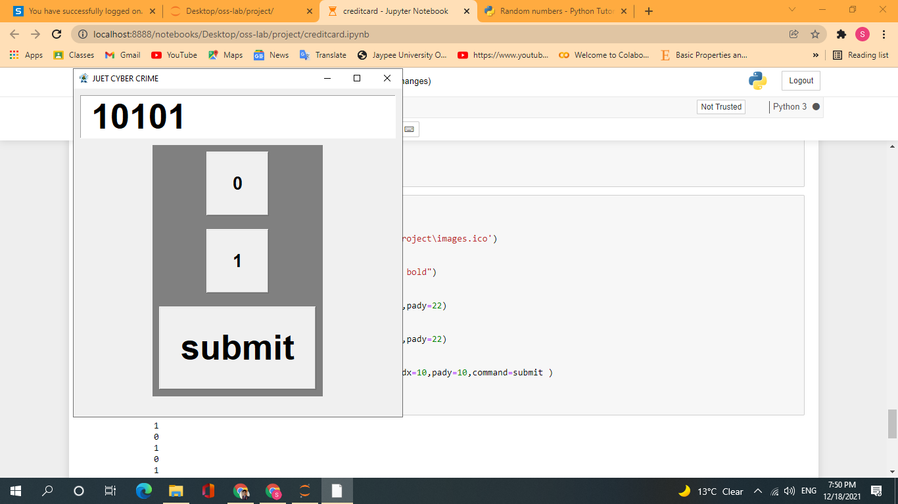  
 | Conclusion/  Remarks: | 1.Using this project we whether find transactions are fraud or Genuine.  - This is front and back end projects
Evaluation/
Marks:

